Letter to Branches
For instant updates: www.cwu.org email: info@cwu.org
150 The Broadway, Wimbledon, London, SW19 1RX
Tel: 020 8971 7200 Fax: 020 8971 7300
General Secretary: Billy Hayes (www.billyhayes.co.uk)

General Secretary: Billy Hayes (www.billyhayes.co.uk)
General Secretary: Billy Hayes (www.billyhayes.co.uk)
General Secretary: Billy Hayes

No. 221 /12 | Ref: 440.23 | Date: 30th March 2012

To: Branches with POSTAL Members

Dear Colleagues,

Royal Mail Group (excluding POL) Revised Transfer Policy and Process

Branches will be aware of CWU HQ’s continuing dialogue with Royal Mail Group to update and revamp the transfer policy and process for individuals who wish to transfer location voluntarily within Royal Mail Group. Following lengthy discussions a revised policy and process has been agreed with Royal Mail Group and endorsed by the Postal Executive.

It is fair to say that the process that was in place had fallen into a state of disrepair and was no longer “fit for purpose”. This is primarily for two reasons.

Firstly as the business goes through the Business Transformation programme the opportunity and choices for individuals who wish to transfer voluntarily to full time vacancies has become limited due to many units facing a surplus situation as a consequence of closures/mergers and/or reductions in headcount.

Secondly, the paper based process was slow to respond to the needs of the business, and more importantly our members. Also, it was not transparent for the individual and was operated remotely. The system being replaced required individuals who wished to transfer to complete a transfer request form, which they had to get from their line manager, and indicate up to a maximum of five locations they wished to transfer to. This was then handed back to the line manager to be signed and then forwarded to the resourcing centre at Sheffield. In addition the request was then subject to the individual satisfying the eligibility criteria of completing six months continuous service and having a clear conduct record, whilst also not being on any stage of the attendance procedure.

These requests were then held on record at Sheffield and compiled on a region by region basis involving 11 individual spreadsheets. The total number of individuals currently on the list is 3200, some of whom have been on the list for a significant number of years.

The information held was more often out of date and many employees no longer wanted/expected to transfer due to changing circumstances.

The current requests are broken down as follows:

- 45.89% of transfer requests specify a minimum of 40 hours
- 20.40% of transfer request specify a minimum of 30-39 hours
- 21.4% of transfer requests specify a minimum 0-29 hours
- 12.27% of transfer requests did not specify a minimum number of hours

The revised system will change the dynamic of requesting a transfer to real time application, when the job becomes available. This will happen by the individual logging onto the Royal Mail website and registering an on line application setting out a criteria of preferred locations within a specified mileage radius, contractual hours, position and type of job. This will also include setting up an email alert that is triggered if/when a job becomes available that meets the individual’s criteria. They will then have to confirm their application and willingness to transfer to this vacancy.

The email alert system and log in details can be either set up to respond to the individuals own computer or to anyone else they may wish to choose including the line manager at their office or friends or relatives.

Listed below are the main features of the previous system as opposed to the revised system.

Previous System

- Imposed by management
- Individuals with attendance warnings or conduct records barred from transferring
- Receiving manager picks the best candidate by telephone interview - without any challenge or appeal process
- If more than one applicant - receiving manager decides who gets placed irrespective of how long individual has been on the list.
- Transfer form application has to be requested from and signed by the individual’s line manager.
- Lip service to any real review, input and monitoring.
- Current process restricts individuals to 5 potential locations.

Revised System

- Policy negotiated and introduced by agreement, including a full joint review
- All individuals on the existing list will be given priority over new applications and placed in the order of length of time on the transfer list
- Thereafter, length of service (seniority with appropriate skills) will be the criteria for filling a vacancy.
- No debarment for individuals who have conduct or attendance warnings- unless disciplinary transfer (for two years) only.
- No telephone interviews or selection criteria involving the receiving manager.
- Individuals can apply for a transfer on line without the knowledge or involvement of their line manager, if they wish.
- Allows individuals larger search criteria with more options of locations.

The process of exceptional circumstances for individuals who have domestic issues and need transfers will remain in place. Also there is no change to the arrangements for surplus staff being given priority due to closures etc.

The revised Transfer Policy is clearly a much more efficient, fairer and transparent system than that previously in place and provides our members with a much simpler process to follow.

The revised policy is being launched along with comms from 1st April 2012 and all existing employees currently on the transfer list will be written to inviting them to confirm their desire to remain on the transfer list. Employees will receive their letters next week and an example is attached to this LTB.

Any enquiries to Bob Gibson’s Office, quoting reference 440.23

Email address: hnutley@cwu.org

Any enquiries to Terry Pullinger’s Office, quoting reference 202.10

Email address: dwyatt@cwu.org

Yours sincerely Yours sincerely
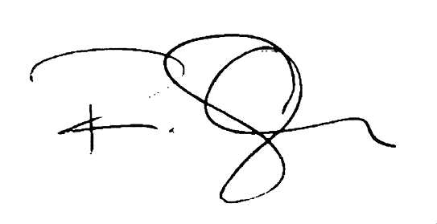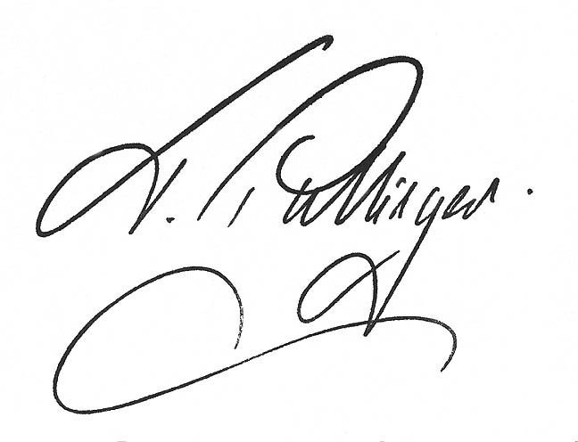
Bob Gibson Terry Pullinger
Assistant Secretary Assistant Secretary

COMMUNICATION WORKERS UNION
URGENT INFORMATION FOR MEMBERS

