Letter to Branches
For instant updates: http//:www.cwu.org email: info@cwu.org
150 The Broadway, Wimbledon, London, SW19 1RX Tel: 020 8971 7200 Fax: 020 8971 7300
General Secretary: Billy Hayes (www.billyhayes.co.uk)

No. 520/14 | Ref: 121.10 | Date: 14th August 2014

To All: Postal Branches with Parcelforce Members
Parcelforce Regional Organisers
Parcelforce Representatives

Dear Colleague

Parcelforce Worldwide Customer Service Selection Process

Branches and representatives will be aware of the commitments given in the past and continuing pay awards for 2010/11 and the Table of Success process. Discussions have now taken place with Parcelforce Worldwide in regard to the resourcing of customer service positions in operational units.

Over the past few years we have worked jointly on a range of initiatives to ensure that we adapt and update our processes and procedures to ensure that we keep up with the pace of change in the highly competitive parcels industry, where the quality of the customer service we provide is a key differentiator and puts the customer at the centre of everything we do.

It was agreed that it would be of benefit to all concerned if there was a generic customer service selection process agreement that could be used by all depots, hubs and processing centre sites.

The attached agreement ensures that the selection process will be open to everyone interested in performing work in customer service. There will be a reserve list providing an equal opportunity to develop customer service and admin skills together with an appeals process, which will ensure a fair and transparent selection criteria for all.

The agreement was endorsed by the Postal Executive at its meeting on 5th August and is attached for your information.

Branches and representatives are requested to ensure that our members are made aware of the contents of this LTB.

Any enquiries in relation to this LTB should be addressed to Terry Pullinger, Assistant Secretary, email dwyatt@cwu.org or shayman@cwu.org quoting reference 121.10.

Yours sincerely

Terry Pullinger
Assistant Secretary

Agreement Between Parcelforce Worldwide And The Communication Workers Union Regarding The Selection Process For The Resourcing Of Customer Service Positions In Operational Units

The ‘Table of Success’ process agreed between Parcelforce Worldwide and the CWU committed both parties to a mutual interest based partnership approach through building relationships, integrating interests and institutionalising a collaborative way of working. We are constantly striving to improve our success and competitive status in the parcel industry and it is extremely important that we not only continue to safeguard the future of the business and our employment security but also create a work environment that can deliver outstanding results.

Against this backdrop both parties recognise the commercial need to adapt and update our processes and procedures to keep up with the fast pace of change in the highly competitive parcels industry. Over the past few years we have worked jointly on a range of initiatives to retain customer services work within the Parcelforce Worldwide network. This activity has included training programmes to provide the right skills for operatives working in customer services and administrative roles and help to professionalise the customer services function in the operation.

This type of work does not fall into the category of a specialist responsibility role. However, it is acknowledged that not all employees would possess the core skills and disposition required to perform a customer services role, even with training and coaching support. Therefore it is agreed that a selection approach primarily based on establishing an employee’s suitability for working in a customer service/administrative environment should be used to fill any vacant roles.

Parcelforce and the CWU have worked together to create a fair and transparent approach, including agreed selection criteria, to be used for employees applying for Customer Service vacancies in Depot, Hub and Processing Centre sites.

THE AGREEMENT

- This agreement between Parcelforce Worldwide and the CWU sets out the agreed processes applicable to customer service and administration duties covered by CWU represented operational grades.

- Both parties agree the need for required skills to maintain the efficiency and effectiveness of the operation in a professional manner. Equally, this agreement will ensure the process is unbiased to any individual, transparent, fair and expands opportunity to all.

- The selection process for duties covered by this agreement will include interview, and test or demonstration of the possession of the appropriate skills.

- These selection principles have been jointly agreed, with both parties having reviewed and revised the interview questions and scoring matrix that will be used as the core part of the selection process.

- It is agreed that appointments must not be influenced by any personal relationship, i.e. blood, marriage, kinship, partnership or friendship etc. The selection process must be transparently fair and ensure decisions are made without regard to any such relationship.

- The interview process should be conducted by two trained interviewers in a fair and impartial manner. Where practicable it is recommended that one of the interviewers should be outside the management line of the candidates, but it is acknowledged that this may not always be operationally possible at smaller depot sites.

- The outcome of any test, interview or determining process must be fully recorded and counselling notes prepared and delivered to all unsuccessful candidates.

- All jobs when vacant in each site will be advertised, with a brief description of the core skills or aptitude required. All employees will be entitled to apply for vacancies at their site. The most suitable candidate as determined by the process will be selected, with seniority being the determining factor where two or more candidates are equally suitable.

- To ensure adequate coverage exists at times of annual leave and sick leave a locally agreed reserve list for each duty will be established. Initially the number of reserves required will be agreed locally, applications for training will be invited and a training programme arranged. Where there is a need to prioritise such training the order will be agreed locally based on the outcome of the selection process. The intention will be to give everybody on the reserve list an equal opportunity to develop their customer service and administration skills to an acceptable level of competence gained through training and “on the job” experience. This will be achieved by providing leave and absence cover for the role on a rotational basis.

- It is important that only candidates who display sufficient aptitude to perform a customer service administration role are accepted onto the official reserve list. Where an individual is unsuccessful in their application for a permanent or reserve customer role, counselling will be provided and, where appropriate, training to meet the required skills will be offered. These individuals would need to re-apply when the next vacancy is advertised and go through the selection process again.

- Unsuccessful candidates will be entitled to an appeal, if they have reasonable grounds for believing that there were procedural shortcomings in the conduct of the selection process which materially affected the outcome of the selection decision. Notification of any intention to appeal must be made within 5 working days, in writing and stating the reason for the appeal. The appeal will be heard by a manager who is at least one grade higher than the original decision maker and who is independent of the initial decision. This can be a Shift/Operations Manager or an equivalent PFW manager in the Hub/Area General Manager’s reporting line, as long as they played no part in the selection process. Any individual may be accompanied or represented by a friend or CWU Representative at the appeal.

- Provided that a reserve list has been established using the selection process outlined in this agreement and is operating in a fair manner as described in 8 and 9 above, future resourcing and selection for customer service and administrative roles will be carried out in line with the following procedure.
Any vacancy will be filled by the most senior suitable applicant from the existing reserve list, as long as the individual is performing as a reserve to an acceptable level, and is not under notice in the Capability/Conduct Procedures. Seniority in this case is defined by the date that the applicant was appointed to the reserve list, and not from the date the applicant entered the business.

Please note that individuals on the reserve list should take every opportunity offered to them to cover a customer service role in order to develop the necessary skills and experience to perform the role if a position becomes vacant. Any unreasonable refusal to provide leave or absence cover will result in the individual being placed at the bottom of the reserve seniority list, or possibly being removed from the list completely in cases where the individual no longer wants to be considered for covering the customer service role.

- Where a vacancy occurs on the reserve list the position will be advertised internally within the site in the first instance. Candidates will be assessed and appointed in line with the terms of this agreement.

- It is recognised that some types of selected duties can be demanding. If an employee needs a temporary change of attendance or duty, for personal or domestic reasons (which must be adequately explained), every effort will be made to meet the individual’s needs.

- Any questions of interpretation, implementation or application of this agreement shall be referred to the signatories of this agreement as a matter of urgency and will be dealt with inside the provisions of the appropriate Procedural/Industrial Relations agreement.

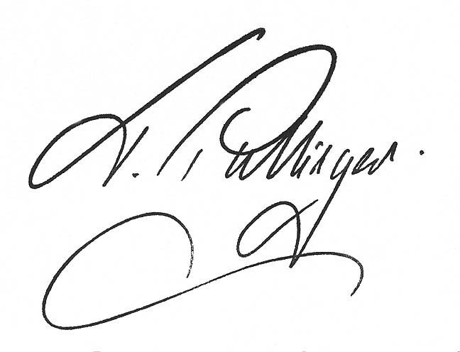
Terry Pullinger Peter Fuller
Assistant Secretary Operations Director
Communication Workers Union Parcelforce Worldwide

Date: 5th August 2014

